**Topics: Descriptive Statistics and Probability**

1. Look at the data given below. Plot the data, find the outliers and find out $μ,σ,σ^{2}$

|  |  |
| --- | --- |
| **Name of company** | **Measure X** |
| Allied Signal | 24.23% |
| Bankers Trust | 25.53% |
| General Mills | 25.41% |
| ITT Industries | 24.14% |
| J.P.Morgan & Co. | 29.62% |
| Lehman Brothers | 28.25% |
| Marriott | 25.81% |
| MCI | 24.39% |
| Merrill Lynch | 40.26% |
| Microsoft | 32.95% |
| Morgan Stanley | 91.36% |
| Sun Microsystems | 25.99% |
| Travelers | 39.42% |
| US Airways | 26.71% |
| Warner-Lambert | 35.00% |

A) Mean=33.27%

Standard deviation=16.95%

Variance=0.0287

Outliers: (Morgan Stanley,91.36%)

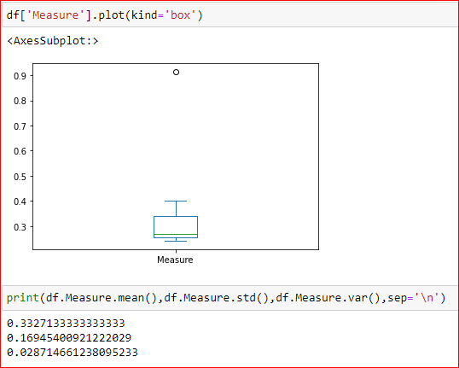



Answer the following three questions based on the box-plot above.

1. What is inter-quartile range of this dataset? (please approximate the numbers) In one line, explain what this value implies.
2. What can we say about the skewness of this dataset?
3. If it was found that the data point with the value 25 is actually 2.5, how would the new box-plot be affected?

A)inner quartile range is the difference between the 75th percentile of the date and the 25th percentile of the data and middle 50% of the data lies in this range.

Inner quartile range of this data=12-5=7

This data is positively skewed

There wont be any outliers in the data anymore. And 25th,50th and 75th percentiles move slightly to the left.



Answer the following three questions based on the histogram above.

1. Where would the mode of this dataset lie?
2. Comment on the skewness of the dataset.
3. Suppose that the above histogram and the box-plot in question 2 are plotted for the same dataset. Explain how these graphs complement each other in providing information about any dataset.

A) the mode of this dataset lies between 4 and 8

The dataset is positively skewed

Both the graphs show that the data is positively skewed. Both of them show an outlier at around 25 and both show the range is from 0 to around 20. Th first graph shows the median is 7 and the second graph shows the median is between 6 and 8.

1. AT&T was running commercials in 1990 aimed at luring back customers who had switched to one of the other long-distance phone service providers. One such commercial shows a businessman trying to reach Phoenix and mistakenly getting Fiji, where a half-naked native on a beach responds incomprehensibly in Polynesian. When asked about this advertisement, AT&T admitted that the portrayed incident did not actually take place but added that this was an enactment of something that “could happen.” Suppose that one in 200 long-distance telephone calls is misdirected. What is the probability that at least one in five attempted telephone calls reaches the wrong number? (Assume independence of attempts.)

A) let p_x=probabiity of exactly x calls getting misdirected.=5Cx*(p^x)*(q^(5-x))

p=probability of a call getting misdirected=1/200

q=probability of a call not getting misdirected=199/200

probability of at least one call misdirected=p_1+p_2+p_3+p_4+p_5

=1-p_0

=1-5C0*(p^0)*(q^5)

=0.0248=2.48%

1. Returns on a certain business venture, to the nearest $1,000, are known to follow the following probability distribution

|  |  |
| --- | --- |
| x | P(x) |
| -2,000 | 0.1 |
| -1,000 | 0.1 |
| 0 | 0.2 |
| 1000 | 0.2 |
| 2000 | 0.3 |
| 3000 | 0.1 |

1. What is the most likely monetary outcome of the business venture?
2. Is the venture likely to be successful? Explain
3. What is the long-term average earning of business ventures of this kind? Explain
4. What is the good measure of the risk involved in a venture of this kind? Compute this measure

A)2000 $ has the most chance of occuring in the given table.

Expectation(x)=Σx*P(x)

=(-2000*0.1)+(-1000*0.1)+(0*0.2)+(1000*0.2)+(2000*0.3)+(3000*0.1)

=800 $

Since the expectation is more than 0, The venture is likely to be successful longterm.

The long term average earning of business of this kind is the expected returns

which is

Expectation(x)=Σx*P(x)

=(-2000*0.1)+(-1000*0.1)+(0*0.2)+(1000*0.2)+(2000*0.3)+(3000*0.1)

=800 $

good mesure of risk involved is variance or standard deviation

variance=E(x2)-E(x)2

=(-20002*0.1)+(-10002*0.1)+(0*0.2)+(10002*0.2)+(20002*0.3)+(30002*0.1)-8002

=1160000

standard deviation=(variance)0.5=1077.03